How to setup range extender mode via management page
Product line: Wireless Model number: A300/A301
We can set range extender mode for A300 to extend our wireless network via button or management page based on web. This article will guide you set range extender mode via UI. Before setting A300, please make sure that you can get internet if you connect your computer to upper router directly. Steps are as follow：
Part 1: Login its homepage
Part 2: Configure extender function

1 Launch a browser and usually it will login automatically. If not，input 192.168.0.254 or re.tendacn.com in the address bar and press Enter.

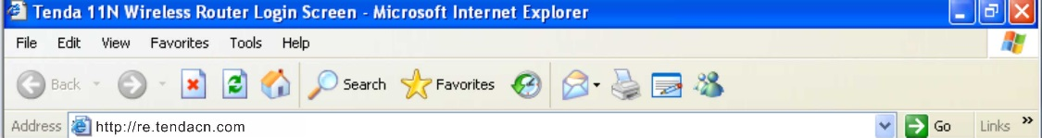

- Enter the default password admin and click OK.

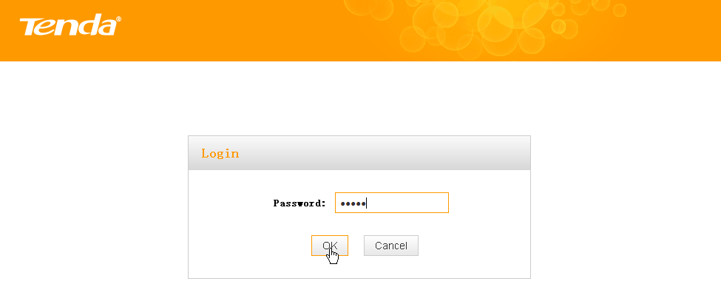

- Then the following page will appear.
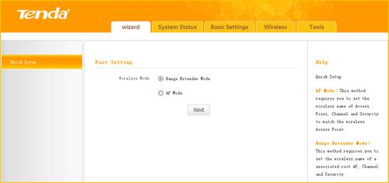

1 Click Wizard, select Range Extender Mode and click Next
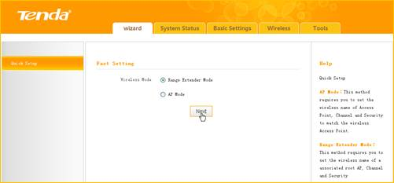
2 Click Open Scan, select the remote router's wireless network (SSID), say Tenda_881218, click OK.
and close Scan.
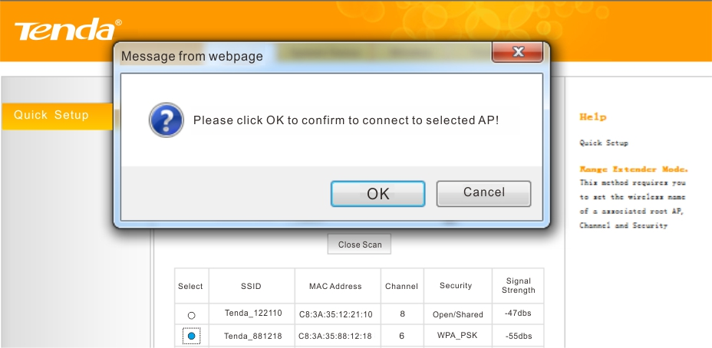
- Enter the remote device’s security key and click Save;
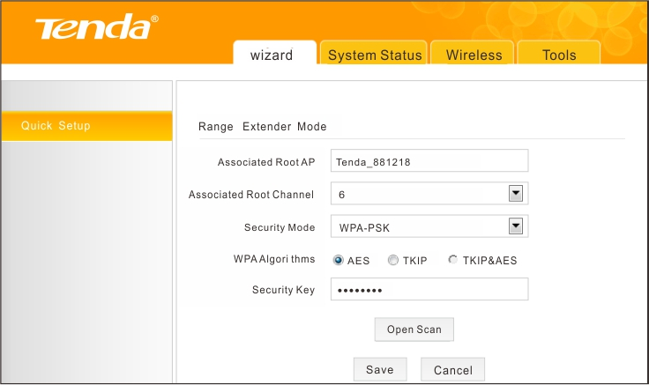
4 In the appearing dialogue box click OK;
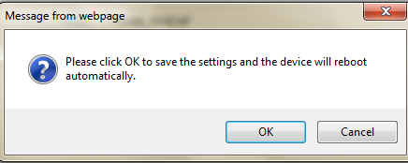
5 Click System Status to check the bridge status. When the bridge status displays Connected, bridged successfully.
